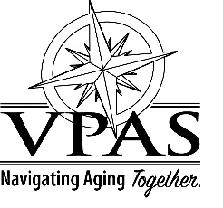

VPAS BOARD OF DIRECTORS
MEETING SCHEDULE 2024

The VPAS Board of Directors will meet every 4th Monday of the following months from 1:30-2:30pm

Meetings will take place at 325 Pine Ave., Waynesboro unless otherwise noted.

January 22, 2024
March 25, 2024
May TBD
July 22, 2024
September 23, 2024
November 25, 2024

