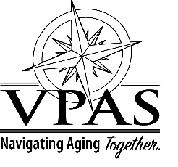

VPAS BOARD OF DIRECTORS
MEETING SCHEDULE 2024

The VPAS Board of Directors will meet every 4th Monday of the following months from 1:30-2:30pm

Meetings will take place at 325 Pine Ave., Waynesboro unless otherwise noted.

January 22, 2024
March 25, 2024
May 27, 2024
July 22, 2024
September 23, 2024
November 25, 2024

